**ASSIGNMENT**

**By**

***Harsh Vardhan Singh***

**2020A1R060**

**1st**

**CSE**



**Model Institute of Engineering & Technology (Autonomous)**

(Permanently Affiliated to the University of Jammu, Accredited by NAAC with “A” Grade)

Jammu, India

2023



**ASSIGNMENT**

**1: Write a C program to find the maximum and minimum element in an array.**

**Input:**

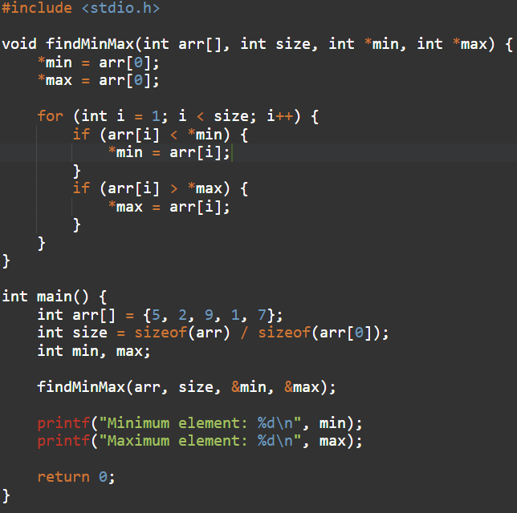

Output:

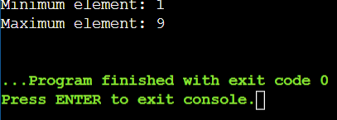

**2: Write a C program for finding largest of three nos in all the methods.**

1. **Using ternary.**

**Input:**

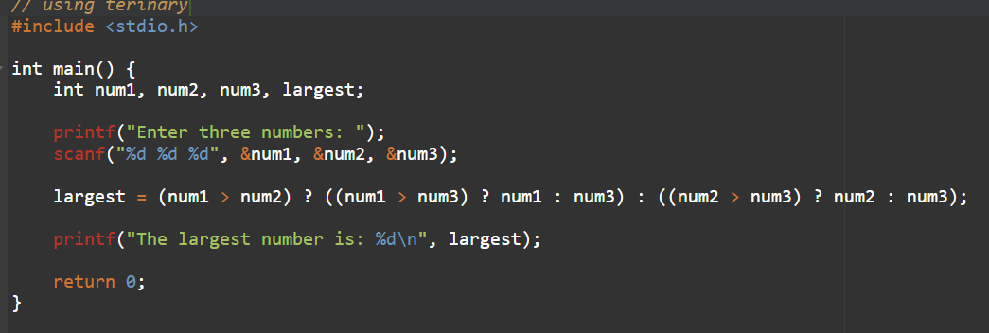

Output:

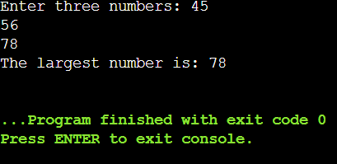

1. **using elseif.**

**Input:**

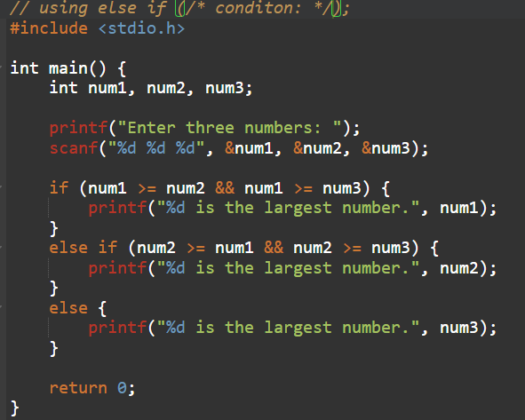

**Output:**

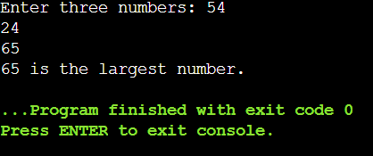

1. nested if

input:

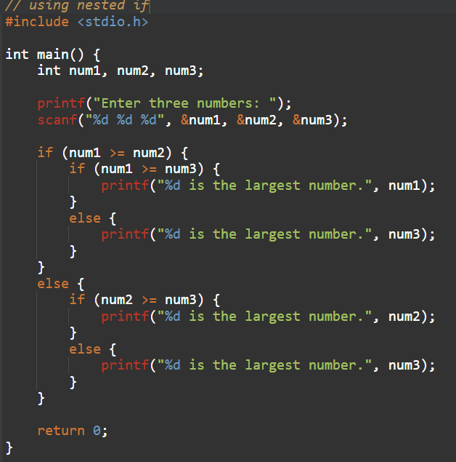

Output:

